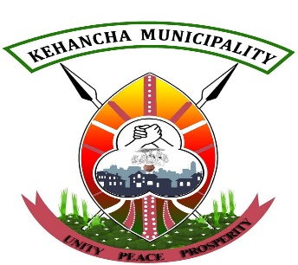

COUNTY GOVERNMENT OF MIGORI

DEPARTMENT OF LANDS HOUSING, PHYSICAL PLANNING AND URBAN DEVELOPMENT

KEHANCHA MUNICIPALITY
P.O. Box 158-40413
KEHANCHA

SOLID WASTE MANAGEMENT PLAN

SEPTEMBER, 2023

Contents
Definition of Terms ........................................................................................................................................ 3
Introduction ................................................................................................................................................... 5
LEGAL FRAMEWORK RELEVANT TO SOLID WASTE MANAGEMENT IN KENYA ......................... 6
SITUATIONAL ANALYSIS ........................................................................................................................... 8
2.1 Waste Streams ....................................................................................................................................... 8
2.2 Environmental Problems of Poor Waste Management ......................................................................... 8 STRATEGIC AREAS AND PROPOSED ACTIONS ................................................................................... 10
3.1 Waste Reduction at Source ................................................................................................................. 10
3.2 Waste Recycling and Composting ...................................................................................................... 10
3.3 Incineration and Waste to Energy Recovery ....................................................................................... 10
3.4 Planning For a Sustainable Solid Waste Management System ........................................................... 11
3.5 Institutional, Organizational, Policy and Legal Reforms .................................................................... 12
3.6 Strategy 6: Capacity Building, Environmental Planning, Education and Awareness ......................... 12
3.7 Management of Hazardous and Special Wastes: ................................................................................ 12
3.8 Resource Mobilization through Public Private Partnerships and Financing Reforms ........................ 12
IMPLEMENTATION, MONITORING AND EVALUATION ..................................................................... 13
Implementation Schedule .............................................................................................................................. 13
Monitoring and Evaluation ............................................................................................................................ 14
References ..................................................................................................................................................... 15

Definition of Terms
Biomedical waste: Any waste which is generated during the diagnosis, treatment or immunization of human beings or animals or in research activities pertaining thereto or in the production or testing of biological and including categories.
Composting: This is the controlled biological decomposition of organic solid waste under aerobic conditions. Decomposition refers to the breaking down into component parts or basic elements. The material form from the composting process is called compost or humus.
Disposal site: Any area of land on which waste disposal facilities are physically located or final discharge point without the intention of retrieval but does not mean a re-use or re- cycling plant or site.
Domestic Waste/ Household Waste: Waste generated from residences.
E-waste: A term encompassing various forms of electrical and electronic equipment that are old, endof-life electronic appliances that have ceased to be of any value to their owners.
Hazardous waste: Waste with properties that make it dangerous, or capable of having a harmful effect on human health and the environment. These wastes require special measures in handling and disposal due to their hazardous properties (e.g. toxicity, ecotoxicity, carcinogenicity, infectiousness, flammability, chemical reactivity) and are generally not suitable for direct disposal into a landfill.
Medical/Healthcare Waste: Any cultures or stocks of infectious agents, human pathological wastes, human blood and blood products, used and unused sharps, certain animal wastes, certain isolation wastes and solid waste contaminated by any of the above biological wastes.
Incineration: A waste treatment process that involves the combustion of organic substances contained in waste materials. Incineration and other high-temperature waste treatment systems are described as "thermal treatment". Incineration of waste materials converts the waste into ash, flue gas, and heat.
Industrial Waste: Waste arising from processing and manufacturing industries or trade undertakings and can take the form of liquid, non-liquid, solid and gaseous substances.
Integrated Solid Waste Management: A practice of using several hierarchy of options (source reduction, recycling, combustion and landfill) of waste management techniques to manage and dispose of specific components of municipal solid waste materials.
Privatization: A form of partnership between public, private, community-based and non-governmental organizations, so as to mobilize all available experiences, talent and resources to solve the household waste management problem.
Public–Private Partnership (PPP): is a government service or private business venture which is funded and operated through a partnership of government and one or more private sector companies.
Recycling of waste: Refers to the processing of waste material into a new product of similar chemical composition.
Reuse: Means waste reused with or without cleaning and/or repairing.
Sanitary Landfill: A method of disposing of refuse on land without creating nuisance or hazards to public health or safety, by utilizing the principles of engineering to confine the refuse to the smallest practical area, to reduce it to the smallest practical volume, and to cover it with a layer of earth or soil at the conclusion of each day’s operation or at such more frequent intervals as may be necessary.
Solid waste: Any solid or semi-solid garbage, refuse, or rubbish, sludge (from any facility involved in the treatment of air, wastewater, or water supply), and other discarded material, including any contained liquid or gaseous material, remaining from industrial, commercial, institutional activities and residential or community activities.
Solid Waste Management: Refers to the activities, administrative and operational, that are used in storage, collection, transportation, recovery, treatment and disposal of solid wastes.
Source Reduction/ Minimization: The reduction, to the extent feasible, in the amount of solid waste generated prior to any treatment, storage, or disposal of the waste.
Source Separation: Refers to any activity that separates waste materials at the point of generation for processing.
Storage: The temporary placement of waste in a suitable location or facility where isolation, environmental and health protection and human control are provided in order to ensure that waste is subsequently retrieved for treatment and conditioning and/or disposal.
SWM infrastructure: All facilities (e.g. landfills, transfer stations, workshops), equipment (e.g. vehicles, rubbish bins, crushers), and public infrastructure (e.g. roads, electrical substations, SWM education programs) necessary for SWM.
Treatment: Any method, technique or process for altering the biological, chemical or physical characteristics of wastes to reduce the hazards it presents.
Waste exchange: This is where the waste product of one process becomes the raw material for a second process.
Waste Generator: Any person whose activities or activities under his or her direction produces waste or if that person is not known, the person who is in possession or control of that waste.

Introduction
Generation of wastes continues to confront man in his living environment. This is as a result of anthropogenic activities which generate waste, especially under conditions of rapid urbanization. The common waste being solid waste, which poses severe impacts on the environment, thus threatening quality of life. Unfortunately, the rise in solid wastes generation has not necessarily been followed by an increase in the capacity to effectively manage the emerging challenges.

Given that Kehancha Municipality has a rapidly growing population; the problem of generation of huge quantities of solid wastes is likely to become more confounding. Currently, about three quarters of the solid waste generated within the Municipality and in the county has a high likelihood of not being uncollected or even unprofessionally handled.

In waste management, the principals of inter- and intra-generational equity, the polluter-pays principle and the precautionary principle prevail. By this plan, it would be possible to address waste management issues in the context of the Environment Management and Co-ordination Act 1999. The latter provides for a comprehensive framework for the development of an Action Plan at any level.

LEGAL FRAMEWORK RELEVANT TO SOLID WASTE MANAGEMENT IN KENYA
In the Constitution of Kenya, Article 42 on Environment provides that- ―Every person has the right to a clean and healthy environment, which includes the right
- To have the environment protected for the benefit of present and future generations through legislative and other measures, particularly those contemplated in Article 69; and
- To have obligations relating to the environment fulfilled. Under Article 69 on Obligations to the Environment, the Constitution provides that –
  - The State shall—
  - encourage public participation in the management, protection and conservation of the environment;
  - Establish systems of environmental impact assessment, environmental audit and monitoring of the environment;
  - Eliminate processes and activities that are likely to endanger the environment; and
  - Utilize the environment and natural resources for the benefit of the people of Kenya.
  - Every person has a duty to cooperate with State organs and other persons to protect and conserve the environment and ensure ecologically sustainable development and use of natural resources.

Part 2 of the fourth Schedule in the Constitution of Kenya also explicitly provides that the County Governments through relevant departments shall be responsible for;
- Refuse removal,
- Refuse dumps and
- Solid waste disposal.

The Environmental Management and Coordination Act (EMCA), 1999 Section 3 of EMCA, 1999 stipulates that - ―Every person in Kenya is entitled to a clean and healthy environment and has a duty to safeguard and enhance the environment.
Section 87 of EMCA 1999 states that –
  - No person shall discharge or dispose of any wastes, whether generated within or outside Kenya, in such manner as to cause pollution to the environment or ill health to any person.
  - No person shall transport any waste other than –
    - in accordance with a valid license to transport wastes issued by the Authority; and
    - to a wastes disposal site established in accordance with a license issued by the Authority.
  - No person shall operate a wastes disposal site or plant without a license issued by the Authority.
  - Every person whose activities generate wastes shall employ measures essential to minimize wastes through treatment, reclamation and recycling.

Environmental Management and Coordination (Waste Management) Regulations of 2006, In the Responsibility of the Generator, Regulation 2 states that:
  - (a) Any person whose activities generate waste shall collect, segregate and dispose or cause to be disposed of such waste in the manner provided for under these Regulations.
Regulation 5 on the Segregation of waste by a generator states that:
  - Any person, whose activities generate waste, shall segregate such waste by separating hazardous waste from nonhazardous waste and shall dispose of such wastes in such facility as is provided for by the relevant Local Authority.

SITUATIONAL ANALYSIS
Kehancha Municipality is rapidly growing population and inhabited by informal settlement dwellers and the middle class. This status has led to an increase in waste generation and complexity of the waste streams.

Over the years waste management was the preserve of the local government authorities. However, these entities failed to develop a culture prioritizing the establishment of proper waste management systems and hence allocated meager resources for its operations. In addition, there was general lack of personnel with requisite technical capability for the improved waste management practices. Still worse the authorities did not have institutional capacities to manage waste. Consequently, the current poor state of waste management has prevailed translating into indiscriminate dumping, uncollected waste and lack of waste segregation across the country.

An analysis of existing practices provides information that forms the basis for administrative and technical considerations leading to the development of this plan.

2.1 Waste Streams
The waste streams within Kehancha Municipality can be categorized as domestic, industrial and hazardous wastes; in addition to e-waste, waste/used oil, waste tyres attributed to growing commercial and industrial activities as well as the marked growth of ICT. The composition of general waste varies considerably between households, businesses, and industries.

Among the types of wastes found in the county are: Domestic Waste, Biomedical Waste, Used Oil and Sludge, E-Waste, Pesticide Waste, Fluorescent Lamps, Construction and demolition waste.

2.2 Environmental Problems of Poor Waste Management
The key environmental problems that are a consequence of poor waste management recorded in Kehancha Municipality are:
- Surface water contamination: Waste from commercial and residential areas end up in water bodies negatively changing the chemical composition of the water. Technically, this is called water pollution, and it affects wetlands and other riparian ecosystems. It also causes harm to animals that drink from such polluted water sources.
- Soil contamination: Hazardous chemicals that get into the soil (contaminants) can harm plants when they are taken-up through their roots. If humans eat affected plants and animals that have consumed such plants as pasture, then there is a high possibility of occurrence of negative impacts on human health.
- Pollution: Bad waste management practices in the county have resulted in land and air pollution which can cause respiratory problems and other adverse health effects to humans as contaminants, are inhaled and absorbed into the lungs proceeding to other parts of body.
- Leachate: The liquid that forms water trickles through contaminated areas is called leachate. It forms a harmful mixture of chemicals that may result in hazardous substances entering surface water, groundwater or soil.
- Municipal wellbeing: Most trading centers within the municipality have poor sanitation, smelly and with waste matter all over the place, an indication of poor living standards in urbanized areas of the municipality.
- Recycling revenue: the municipality does not invest in recycling and proper waste control thus missing out on revenue from recycling, green job opportunities that come from recycling, and potential for establishment of organic fertilizer ventures and even a factory.

STRATEGIC AREAS AND PROPOSED ACTIONS
Based on the baseline surveys; existing literature, community and stakeholder consultations, and existing county development plans, policies and laws, below are some of SWM prioritized strategic areas.

3.1 Waste Reduction at Source
Waste reduction at source is the first priority in the ISWM hierarchy. In this strategic plan, source reduction implies reducing the volume of waste at the source/ point of generation by changing the material-generating process. It includes incorporating reduction in the design, manufacture, sale, purchase, and use of products and packaging.
Source reduction strategy objective is to reduce the number of materials the municipality will produce and the harmful environmental effects associated with their production and disposal. It includes: reduced material use in product manufacture, increased useful life of a product through durability and ease-to-repair, material reuse, reduced/ more efficient consumer use of materials, and increased production efficiency resulting in less production of waste. Source reduction will offer several opportunities for cost savings for the Municipality management which include direct savings on waste collection, transportation, and disposal costs.

3.2 Waste Recycling and Composting
Recycling is the process by which materials otherwise destined for disposal are separated at source, collected, processed, and remanufactured or reused. This is increasingly being adopted by urban communities as a method of managing municipal waste and source of income for the urban poor. Recycling program will divert a significant percentage of municipal, institutional, and business waste from disposal and can help to control waste management costs by generating revenue through the sale of recyclable materials.
Municipality management shall aim at continually providing consistent stream of high-quality (free of contaminants) recovered waste materials that meet the standards of the marketplace and limit health risks to workers involved in the sector and therefore consider an upstream sorting of the recyclable waste.

3.3 Incineration and Waste to Energy Recovery
Incineration is a waste treatment process that involves the combustion of organic substances contained in waste materials. Incineration and other high-temperature waste treatment systems are described as "thermal treatment". Incineration of waste materials converts the waste into ash, flue gas, and heat.
It significantly reduces the necessary volume for disposal. Furthermore, incineration has particularly strong benefits for the treatment of certain waste types such as clinical wastes and certain hazardous wastes where pathogens and toxins can be destroyed by high temperatures.
Incinerators may emit fine particulate, heavy metals; trace dioxin and acid gas, even though these emissions are relatively low from modern incinerators. Other concerns include proper management of residues: toxic fly ash, which must be handled in hazardous waste disposal installation as well as incinerator bottom ash, which must be reused properly. Incineration is recommended for Kehancha Municipality since the global warming potential of the landfill gas emitted to atmosphere is approximately 30% higher than the amount of Carbon dioxide (CO2) that would be emitted by combustion process.

3.4 Planning For a Sustainable Solid Waste Management System
This strategy focuses on the planning of sustainable storage, collection, transportation and disposal systems. Storage, collection, transport and disposal are the four essential elements of any solid waste management system. Compatibility between each of the three stages of storage, collection and transport is essential to ensure economic operation. The objective of this strategy is to partly containerize storage, collection and transport system, which does not allow the waste material to come in contact with the ground at any stage of the collection system.

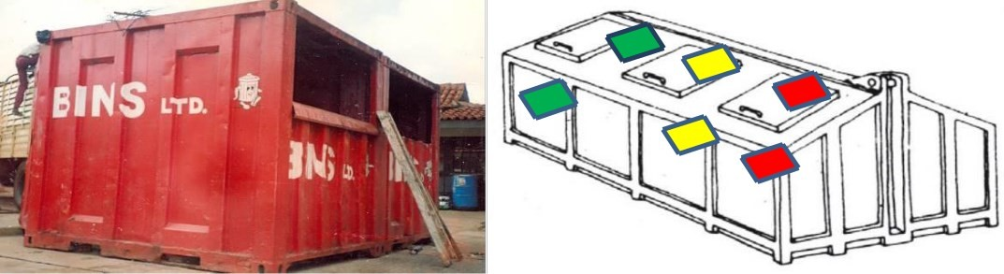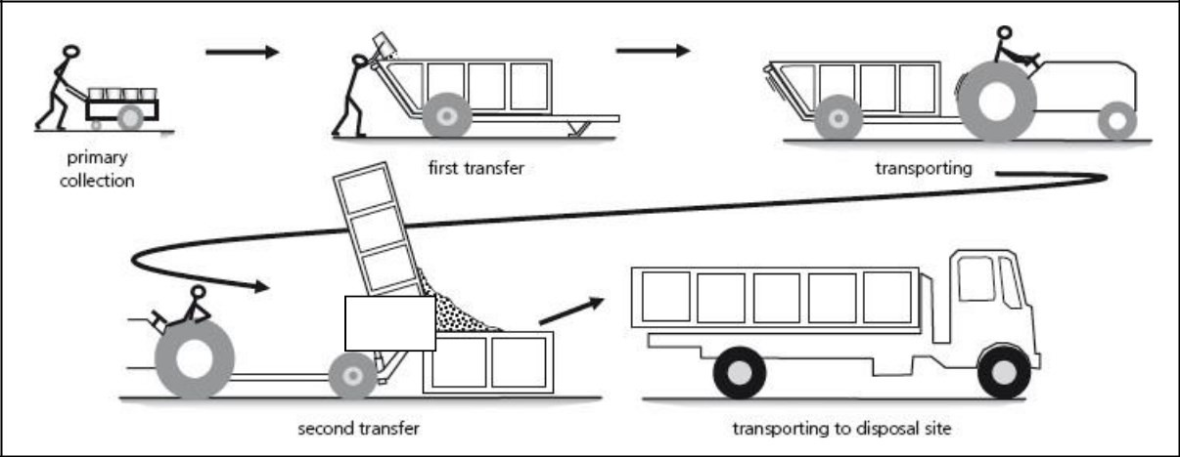

Figure 1: Proposed Waste Collection System

3.5 Institutional, Organizational, Policy and Legal Reforms
After reviewing the strengths and weaknesses (status) in the existing organizational set-ups to manage solid waste in the municipality, reforms are proposed as follows:
- Institutional reorganization of the relevant department handling solid waste
- Establishment of the Ward-Unit/ Community-Based / Nyumba Kumi/ Residents
- Establishment of the ISWM Policy and Legal Reforms

3.6 Capacity Building, Environmental Planning, Education and Awareness
The municipality has limited capacity and skills in waste management for both the public and the private sector. A high degree of collaboration will be required across various departments of the municipality in order to raise sufficient capacities for the purpose. There is need to carry out preliminary waste awareness initiatives among individuals as well as the public and private institutions to improve on knowledge and skills on waste handling and how to minimize the associated risks. There is also need to enhance collaboration and partnership with local traders and investors and the government agencies to ensure that knowledge and skills are transferred and undertake training programs for trainers.
3.7 Management of Hazardous and Special Wastes:
The proposed strategy is to separate waste at source using the 3-colour system in order to maximize the collection of hazardous materials with a view to reducing the environmental and health impacts of any unregulated waste. All hazardous waste should be handled using NEMA national standards, Waste Regulations of 2006 and guidelines during the strategic period.

3.8 Resource Mobilization through Public Private Partnerships and Financing Reforms
This strategy outlines recommendations of resource mobilization through the application of the Public Private Partnerships (PPP) approach and undertaking various financing reforms at the Municipality.

IMPLEMENTATION, MONITORING AND EVALUATION
Daily solid waste collection schedule:
This involves daily cleaning of our streets, Bus Park, markets and the County Government Office compounds. There is also collection of waste from waste bins within the Municipality to receptacles/collection Centers and transportation by tractors/lorry from receptacles to the dumpsite. Streets’ cleaning is done by the County Government in partnership with the contractor.
DAY | SWEEPING OF  STREETS, MARKETS,  BUS PARK, TAXI PARK | COLLECTION TO  RECEPTACLES  FROM BINS AND  STREETS | COLLECTION TO  ALUPE DUMPSITE
MONDAY | ✓ | ✓ | ✓
TUESDAY | ✓ | ✓ | ✓
WEDNESDAY | ✓ | ✓ | ✓
THURSDAY | ✓ | ✓ | ✓
FRIDAY | ✓ | ✓ | ✓
SATURDAY | ✓ | ✓ | ✓
SUNDAY | NO ACTIVITY

Implementation Schedule
This strategy will be implemented in phases and the strategies will be categorized into, short- term, mid-term and long-term strategies as indicated in Table below.
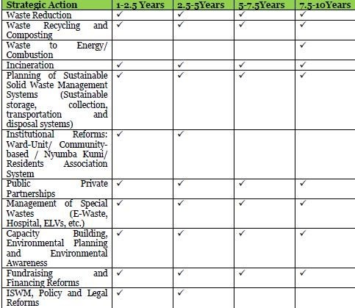

Monitoring and Evaluation
Monitoring and evaluation is an important aspect of strategy implementation that ensures that actions and projects are implemented in a cost effective and efficient manner according to what is proposed in this policy document. The following are recommended as part of M&E
- Monthly Progress Report
- Annual Strategy Report
- Mid-Term Evaluation Report
- Terminal Evaluation Report

References
Integrated Solid Waste Management Plan for Nairobi City, Kenya: Situation Analysis & Detailed Action Plan.
Kisumu Integrated Solid Waste Management Plan (KISWaMP)

