

MUNICIPALITY OF MIGORI
COUNTY GOVERNMENT OF MIGORI

ANNUAL REPORT AND FINANCIAL STATEMENTS
FOR THE FINANCIAL YEAR ENDED
30TH JUNE 2023

Prepared in accordance with the Accrual Basis of Accounting Method under the International Public Sector Accounting Standards (IPSAS

TABLE OF CONTENTS
1. TABLE OF CONTENTS ii
2. KEY ENTITY INFORMATION AND MANAGEMENT iii
4. KEY MANAGEMENT TEAM ix
5. MUNICIPALITY BOARD CHAIRPERSON’S REPORT x
6. REPORT OF THE MUNICIPALITY MANAGER xi
7. STATEMENT OF PERFORMANCE AGAINST PREDETERMINED OBJECTIVES FOR THE FY 2022/2023 xii
8. CORPORATE GOVERNANCE STATEMENT xiii
9. MANAGEMENT DISCUSSION AND ANALYSIS xiv
10. ENVIRONMENTAL AND SUSTAINABILITY REPORTING xiv
11. REPORT OF THE MUNICIPALITY BOARD MEMBERS xvii
12. STATEMENT OF MANAGEMENT’S RESPONSIBILITIES xviii
13. REPORT OF THE INDEPENDENT AUDITOR xx
14. STATEMENT OF FINANCIAL PERFORMANCE FOR THE YEAR ENDED JUNE 30, 2023. １
15. STATEMENT OF FINANCIAL POSITION AS AT JUNE 30, 2023 ２
17. STATEMENT OF CASH FLOWS FOR THE YEAR ENDED JUNE 30, 2023 ４
18. STATEMENT OF COMPARISON OF BUDGET & ACTUAL AMOUNTS FOR THE YEAR ENDED JUNE 30, 2023 ５
19. SIGNIFICANT ACCOUNTING POLICIES ６
20. NOTES TO THE FINANCIAL STATEMENTS １１
21. ANNEXES １４
- KEY ENTITY INFORMATION AND MANAGEMENT
Background Information
Municipality of Migori is established by and derives its authority and accountability from Urban Areas and Cities Act No. 13 of 2011 and Cities and Municipal Charter on 28th December, 2018. The Municipality is under the County Government of Migori and is domiciled in Kenya.

Principal Activities
Background Information
Municipality of Migori is established by and derives its authority and accountability from Urban Areas and Cities Act No. 13 of 2011 and Cities and Municipal Charter on 20th March 2020. The Municipality is under the County Government of Migori and is domiciled in Kenya.

Principal Activities
The main functions of the municipality are drawn from section 20 of urban areas and cities act, 2011 and the municipal charter. The functions were officially transferred to the municipality vide Gazette Notice no 2384 of 20th March 2020. These include but not limited to:
(a) Oversee the affairs of Municipality of Migori;
(b) Develop and adopt policies, plans, strategies and Programmes, and set targets for delivery of services;
(c) Formulate and implement integrated development plan;
(d) Maintain a comprehensive database and information system of the administration and provide public access thereto upon Payment of a nominal fee to be determined by the board;
(e) Administer and regulate its internal affairs;
(f) Implement applicable national and county legislation;
(g) Enter into such contracts, partnerships or joint ventures as it may consider necessary for the discharge of its functions as required under the law;
(h) Monitor and, where appropriate, regulate municipal services where those services are provided by service providers other than the board of the municipality;
(i) Prepare its budget for approval by the county executive committee and administer the budget as approved;
(j) Monitor the impact and effectiveness of any services, policies, programmes or plans;
(k) Establish, implement and monitor performance management systems;
(l) Facilitate and regulate public transport;
(m) Promote a safe and healthy environment; and
(n) Perform such other functions as may be delegated by the county government or as may be provided for by any written law.
(2) The functions performed by the board of municipality under this Act shall, in the case of a town, be performed by a committee appointed.
Municipality Of Migori Board
Ref | Position | Name
 | Chairman of the Board | Mandela Robert Omondi
 | County Executive Committee Member responsible for Cities and Urban areas. | Hon.Eng.John Owuor Kobado
 | Board Member 1 | Truphosa Adhiambo Adawo
 | Board Member 2 | Willis Aluoch Aluoch
 | Board Member 3 | James Ogutu Odindo
 | Board Member 4 | Paul Odhiambo Okelo
 | Board Member 5 | Daniel Frank Akelo
 | Board Member 6 | Spirim Kwamboka Oloo
 | Municipality Manager | Onyango Dismas Owino

(Input names of all the members who held office during the period)
Fiduciary Management-

Ref | Position |  | Name
1 | Municipality Manager |  | Dismas Owino
2 | Directors/Head of departments  ` | Accountant | Ruth Adhiambo
2 | Directors/Head of departments  ` | Administrator Municipality | George Olumwa
2 | Directors/Head of departments  ` | Procurement Officer | Peter Otieno Tindi

Fiduciary Oversight Arrangements
- Audit and Risk Management Committee
The Board has this committee headed by Willis Aluoch Aluoch
- County Assembly Committees (The Committee of Land is the one dealing with Municipality Issues)
- Committees of the Senate

Registered Offices
P.O. Box 1172, 40400 Suna Migori
Land Building Next to Court Building
Along Government Road
KENYA

- Contacts
Telephone: (+254) 720391392
E-mail: migorimunicipality@migori.go.ke
Website: www.migori.go.ke

Bankers
Commercial Banks-
Kenya Commercial Bank –
- Municipality of Migori Urban Development Grant: Account No. 1250199514
- Municipality of Migori: Account No. 1272575837
- Municipality of Migori Urban Development retention: Account No. 1316545555
- Independent Auditor
Auditor General
Office of the Auditor General
Anniversary Towers, University Way
P.O. Box 30084
GPO 00100
Nairobi, Kenya
- Principal Legal Adviser
The Attorney General
State Law Office
Harambee Avenue
P.O. Box 40112
City Square 00200
Nairobi, Kenya

Name | Details of qualifications and experience
- Board Member 1  Mandela Robert Omondi   | 28 years old  Has Degree in Public Health and Higher Diploma in Project Management
- Board Member 2  Truphoser Adhiambo Adawo   | 51 years old  Has Diploma in Social Work and Degree in Sociology(On Going)
- Board Member 3  Daniel Frank Akello  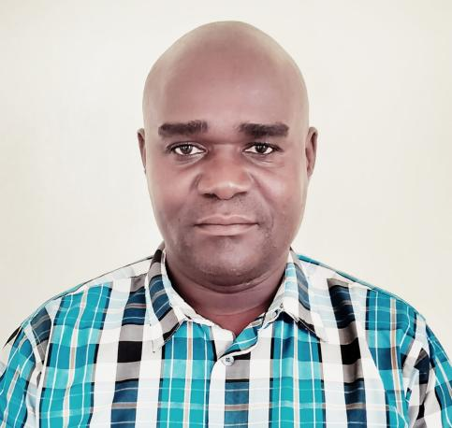 | 44 Years old  Has Degree in Public Policy and Administration, Certificate in Agriculture and Certificate in Research and Ethics
- Board Member 4  Willis Aluoch Aluoch 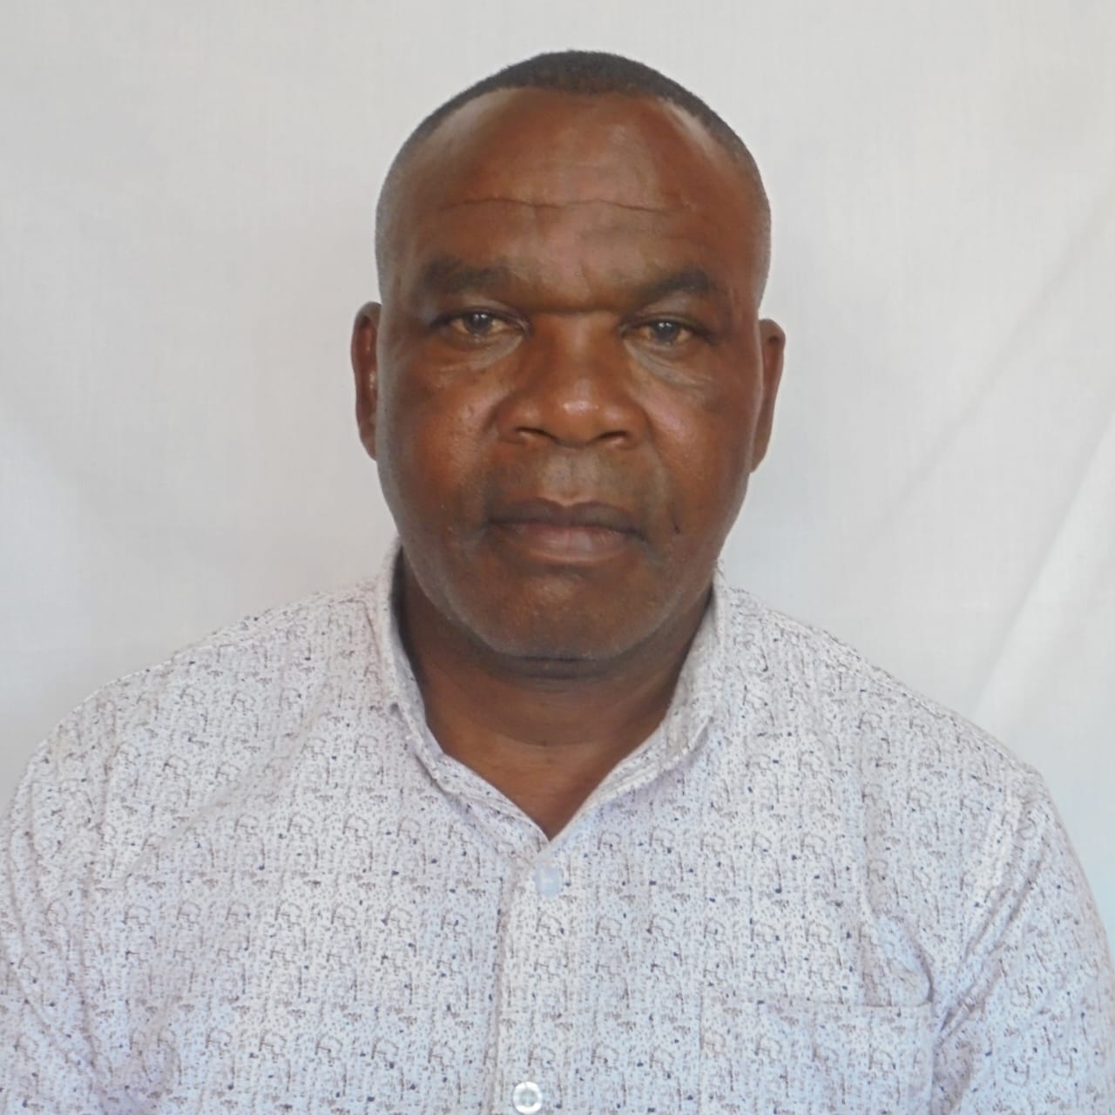 | 59 years old  Diploma in Special Education and Degree in Special Education(On going)
- Board Member 5  James Ogutu Odindo  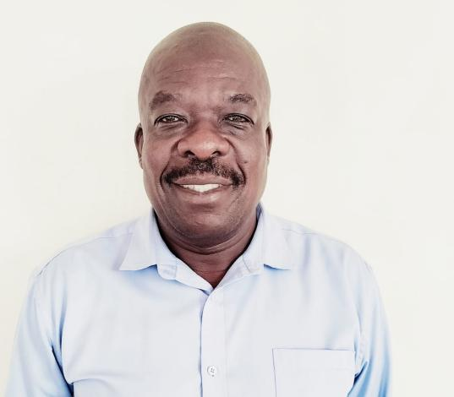 | 59 Years old  Diploma in Insurance(CII),Diploma in Human Resource Administration
- Board Member 6  Paul Odhiambo Okello  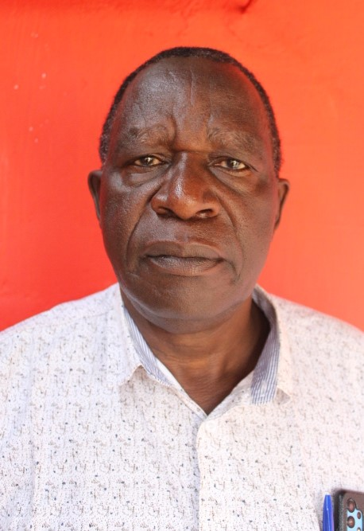 | 64 Years old  Degree in education(economics and business studies)  Master’s in Education Management(on going)
- Board Member 7  Spirim Kwamboka Oloo  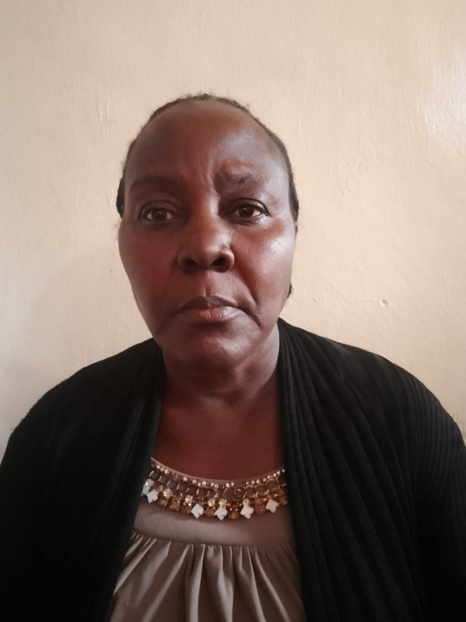 | 57 Years old  Diploma in Theology
- Board Member 7  Dismas Owino Onyango  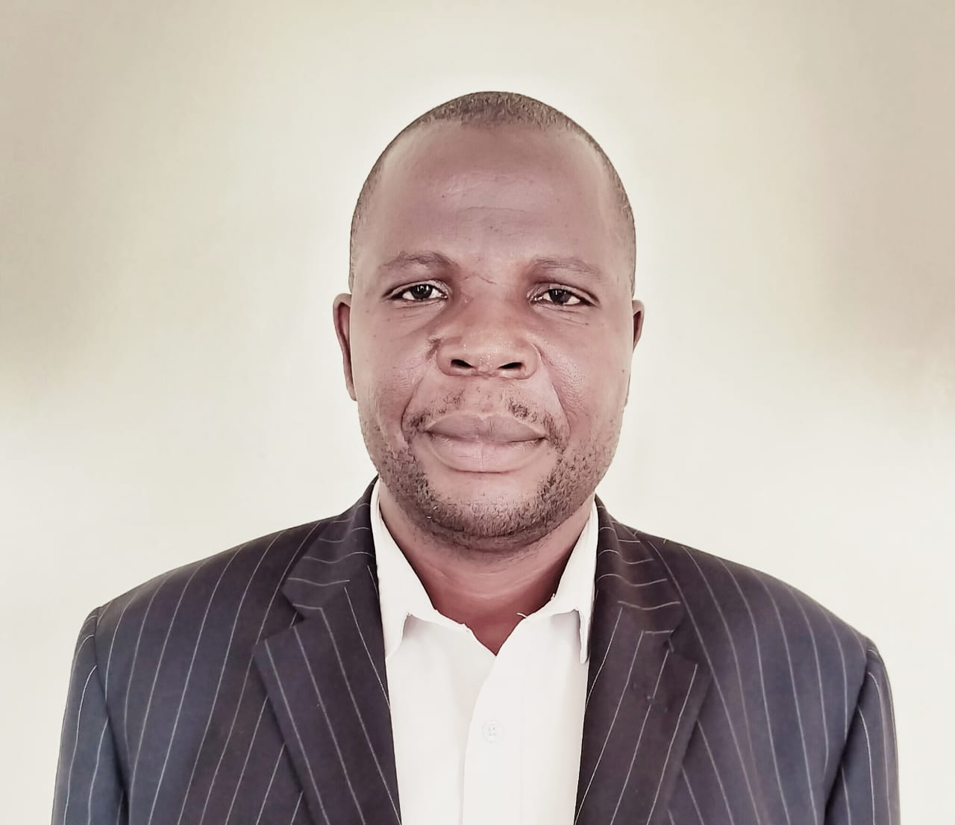 | 50 years old  Degree in Education

4. KEY MANAGEMENT TEAM
Name | Details of qualifications and experience
- Manager 1:  Onyango Dismas Owino | DOB: 21/09/1973  Bachelor’s Degree in Education
- Member 2:  Ruth Adhiambo (Accountant) | Certified Public Accountant(III)
- Member 3: George Olumwa (Administrator Municipality) | Diploma in Education
- Member 4  Peter Otieno Tindi (Procurement Officer) | Masters Business Administration
- Member 5:  Teresa Aoko (Clerical Officer) | O-Level

5. MUNICIPALITY BOARD CHAIRPERSON’S REPORT
The Municipality was allocated Kshs. 63, 882,223 whereby kshs.10, 185,138 was recurrent expenditure and kshs. 53,697,085 was for development. The development components were for the construction of Migori Recreational Park in the Omboo Forest Land, and Municipal roads.

The Municipality had a number of strategic challenges such as Low budget allocation for development. The municipality was only able to construct the recreational park. The Municipality would wish to have more budget allocation to; improve infrastructural services within the Municipality, promoting clean and safe environment by availing resources to clean the Town regularly and unclogging the drainages to manage storm water management and to enhance disaster preparedness and response. The Municipality will also need enough resources for promoting good governance and resources mobilization for the Municipality. In essence we need more resource allocation to have these done.

The Municipality had experienced a number of risks such as the functional/Organizational risks whereby the County Government of Migori through Lands department have not transferred all the functions to the Municipality as per the Urban Areas and Cities Act, 2011 No. 13. Other departments within the County Government have refused to shed off the roles as stipulated by the Municipal Charter, this is Corporate Governance Challenge.

Financial and Fiscal Risks are also espoused as the municipality always received operational resources late and sometimes do not receive at all and this normally hampers enhancement of corporate governance within the Municipality as the By-laws cannot be made on time, the strategic plan cannot be reviewed on time, the Annual Plans and Integrated Development Plans cannot be reviewed on time and public participation which is enshrined in the Urban Areas and Cities Act in section 22, Article 10, 118, 196 (b) and article 232 of the constitution

……………………………………………….
Name: Robert Omondi Mandela
Chairperson of the Board

6. REPORT OF THE MUNICIPALITY MANAGER

The Municipality was allocated Kshs. 63, 882,223 whereby kshs.10, 185,138 was recurrent expenditure and kshs. 53,697,085 was for development. The development components were for the payments of works and pending bills which includes construction of Migori Recreational Park in the Omboo Forest Land, and Municipal roads

The Municipality had a number of strategic challenges such as Low budget allocation for development. The municipality was only able to construct the recreational park. The Municipality would wish to have more budget allocation to; improve infrastructural services within the Municipality, Promoting clean and safe environment by availing resources to clean the Town regularly and unclogging the drainages to manage storm water management and to enhance disaster preparedness and response. The Municipality will also need enough resources for promoting good governance and resources mobilization for the Municipality. In essence we need more resource allocation to have these done.

The Municipality had experience a number of risks such as the functional/Organizational risks whereby the County Government of Migori through Lands department have not transferred all the functions to the Municipality as per the Urban Areas and Cities Act, 2011 No. 13. Other departments within the County Government have refused to shed off the roles as stipulated by the Municipal Charter, this is Corporate Governance Challenge.
Financial and Fiscal Risks are also espoused as the municipality always received operational resources late and sometimes do not receive at all and this normally hampers enhancement of corporate governance within the Municipality as the By-laws cannot be made on time, the strategic plan cannot be reviewed on time, the Annual Plans and Integrated Development Plans cannot be reviewed on time and public participation which is enshrined in the Urban Areas and Cities Act in section 22, Article 10, 118, 196 (b) and article 232 of the constitution.

…………………………………………………….
Name: Onyango Dismas Owino
Municipality Manager

7. STATEMENT OF PERFORMANCE AGAINST PREDETERMINED OBJECTIVES FOR THE FY 2022/2023
Introduction
Section 164 (2) (f) of the Public Finance Management Act, 2012 requires that, at the end of each financial year, the Accounting Officer for a County Government entity shall prepare financial statements in respect of the entity in formats to be prescribed by the Accounting Standards Board including a statement of the county government entity’s performance against predetermined objectives. The key development objectives of the Municipality of Migori plan are to:

- Provide quality physical infrastructure.
- Urban governance and administration
- Safe and healthy environment

Below is the progress on attaining the stated objectives:
Program | Objective | Outcome | Indicator | Performance
Physical Infrastructure | To enhance connectivity | To provide physical infrastructure within the Municipality | Length of Road constructed and Maintained | In the F/Y under review 1.4 KM was maintained by the KURA to bitumen standards
Urban Governance Administration | To enhance good Governance within the Municipality | Developing appropriate tools for Governance and administration - | The By-Laws made by the Municipality  Reviewed Strategic Plans and Annual Plans | -For this Financial Year a draft By-laws were reviewed
 | Creation of more open Spaces within the Municipality | To enhance recreational activities within the Municipality | The Municipality has made various designs for recreational Parks within the Municipality | We have two Designs for recreational parks
 | Construction of migori recreational park. | Enhanced recreational activities within the municipality | Recreational park constructed | One recreational park available

8. CORPORATE GOVERNANCE STATEMENT
The Board of Municipality are appointed by the County Public Service Board then vetted by the County Assembly. The Role of the Board members are stipulated by the Urban Areas and Cities Act, 2011, No. 13. Since their engagement the Board Members have been inducted once in January 2020. The Board Members have been trained on Budgeting and implementation process in Mbita on Making of by- laws for the Municipality.

The Board has had a number of meetings, these are:- ordinary meetings, Four (4) meetings were held as per the Urban Areas and Cities ACT of 2011 No. 13 and all members attending. The board had also 4 extra ordinary meetings (special meetings) with all Board members attending.

The Board had also other Non-Formal Meetings such as Committee meetings, with various committee meetings and other ad Hoc meeting especially when the Board was deliberating over the allocation of the kiosks at ombo with respective members of Town planning Committee attending.

The Board Have no Service Charter as Functions not transferred to the Municipality. Hence it is not possible for service charter as most of the functions still being done by the other departments.
The remuneration of the Board has been set by the Salary and Remuneration Commission (SRC) as Chair to earn 12,000 per meeting, Vice Chair to earn 10,000 kenya shillings and other Board Members to get 8,000 per sitting. The Board Members are engaged on part time basis. The Governance Audit has never been done as the Board is battling with the Transfer of Functions as stipulated by the Urban Areas and Cities Act

MANAGEMENT DISCUSSION AND ANALYSIS
The Municipality was allocated Kshs. 63, 882,223 whereby kshs.10, 185,138 was recurrent expenditure and kshs. 53,697,085 was for development. We managed to absorb Kshs 7,361,668 (72%) and kshs 32,576,587(61%) for Recurrent and development respectively.

ENVIRONMENTAL AND SUSTAINABILITY REPORTING
Municipality of Migori exists to transform lives. This is our purpose; the driving force behind everything we do. It’s what guides us to deliver our strategy, which is founded on 6 pillars: putting the residents/Citizen first, delivering relevant goods and services, and improving operational excellence. Below is a brief highlight of our achievements in each pillar.

- Sustainability strategy and profile
Municipality of Migori was formed on December 28th, 2022 with a charter signed by the His Excellency the Governor of Migori County. Municipality of Migori is one of the 59 Municipalities in Kenya and it is located to the South West of Kenya in Migori County. It is the Headquarter of County Government of Migori and a host of main National Government Offices and other institutions including Migori Main Prison and Level Four Referral Hospital. All the County Government offices are in this Municipality.

Geographically, it is of coordinates 11⁰ 4’ 0¹¹ South, 34⁰ 28’ 0¹¹ East, 371KM West of Nairobi. It is 182 KM South of Kisumu Town through the Migori Kisumu A1 road and 31.4Km North of the Tanzania Border.

The Town enjoys an extensive Connection to the neighbouring counties through the International Trunk road A1 and other Roads. Lake Victoria which is shared by Kenya, Uganda and Tanzania is approximately 55 KM away through Muhuru Road. Masaai Mara and Serengeti Game parks in Kenya and Tanzania respectively is drive away from the Town. Municipality of Migori is the main Urban Area in the Region and is cosmopolitan.

The set-up of Municipality is anchored on the enactment of Urban Areas and Cities Act, 2011 No. 13. In the first five years of the Counties the Urban Areas and Cities Act, 2011 was never implemented as most of the counties did not focus on management of towns until in 2018 when the World Bank brought the Kenya Urban Support Programme as an incentive to counties to create the Urban institutions in terms of administration and Management until managers were put in place. The Kenya Urban Support programme also implemented some infrastructures within the Town.
The main challenge of Municipality of Migori is that, functions have not been transferred by the various departments of the county and they do not have technical staff to these functions once given. The Municipality enjoys Political passion and goodwill for its survival within the county Government set up and hopefully within the shortest time possible, all the functions will be transferred. The other challenge is the low resource allocation by the County treasury for the Municipality to perform its work.

- Environmental performance
The Municipality has mobilized the residents about solid waste management since waste are generated everyday by the traders and other urban dwellers, The Municipality have also mounted waste bins in various strategic points within the town. The department of Environment have made an Environment bill which has gone through the County Assembly and passed as a law a waiting public participation to be implemented. The municipality is also making the By-laws to guide on waste management within the Municipality. The By law is at the draft stage.

The main challenge is the collection of wastes from their temporary transfer stations where sometimes the Environment department takes long to collect the wastes to the dump sites. The function of keeping town healthy and safe has been transferred to the Municipality but no resource for this function. We only depend on the department of environment which also becomes incapacitated sometimes interms of fuel and machines breakdowns.

The Municipality has robust plans to manage wastes within the town, first is to periodically purchase skips and skip loaders to minimize the waste accumulation within the town. The Municipality also intend to purchase the tractor for periodical transport of wastes and to mount more waste bins in the town.

- Employee welfare
Give account of the policies guiding the hiring process and whether they take into account the gender ratio, whether they take in stakeholder engagements and how often they are improved. Explain efforts made in improving skills and managing careers, appraisal and reward systems. The Municipality should also disclose their policy on safety and compliance with Occupational Safety and Health Act of 2007, (OSHA).
The recruitment is centralized at the County Public Service Board. Municipality has five fully deployed staff for the entity that is the Accountant, Clerical officer, administrator, procurement officer and the manager. Degree holder is one, that is, the Manager.

The Staff at the municipality are periodically appraised by the Manager who is their Supervisor to enhance their performance to achieve overall goal of the County.

Generally, the salaries of the staff are regulated by the Salaries and Remuneration Commission (SRC) and under this year the accountant was promoted to higher job group due to her exemplary service.
The municipality has no stand-alone offices- the entity has one room at the lands Department with all its staff. The entity is not visible. We need to construct an office for the Municipality to prevent crowding in the office and to enhance confidentiality at the work place. The OSHA policy is not in place.

- Market place practices
The organisation should outline its efforts to:
- Responsible competition practice. The Municipality ascribe to values and principles of Good Governance as articulated in article 10 & 232 of the constitution. The Ethics and Anti-corruption act of 2003 and the principle and values of the public service as stipulated in article 232 of the constitution.

- Responsible Supply chain and supplier relations. The procurement is centralized at the Supply and Chain department of the County. The Municipality still rely on the Department in Budgeting and procurement process.
- Responsible marketing and advertisement as per the public service principles
- Product stewardship. This is dealt with the department of Trade

- Community Engagements
The Entity during the under review organized the community service day in collaboration with Kenya red Cross Society to do Cleaning of the Main Highway and the Bus Park and unclogging of drainages.

REPORT OF THE MUNICIPALITY BOARD MEMBERS

The Board Members submit their report together with the audited financial statements for the year ended June 30, 2023 which show the state of the Municipality affairs.

Principal activities
The principal activities of the Municipality are as stipulated in section 20 of the urban areas and cities Act 2011

Performance
The performance of the Municipality for the year ended June 30, 2023

Board Members
The members of the Board who served during the year are shown on the previous pages. The changes in the Board during the financial year are as shown below:

Auditors
The Auditor General is responsible for the statutory audit of the Municipality in accordance with Article 229 of the Constitution of Kenya and the Public Audit Act 2015.

………………………………………….
Name: Owino Dismas Onyango
Secretary of the Board

STATEMENT OF MANAGEMENT’S RESPONSIBILITIES

Section 180 of the Public Finance Management Act, 2012 requires that, at the end of each financial year, the Accounting Officer of the Municipality established by Urban Areas and Cities Act No. 13 of 2011 shall prepare financial statements in accordance with the standards and formats prescribed by the Public Sector Accounting Standards Board.

The Municipality manager is responsible for the preparation and presentation of the Municipality’s financial statements, which give a true and fair view of the state of affairs of the Municipality for and as at the end of the financial year ended on June 30, 2023. This responsibility includes: (i)maintaining adequate financial management arrangements and ensuring that these continue to be effective throughout the reporting period, (ii) maintaining proper accounting records, which disclose with reasonable accuracy at any time the financial position of the Municipality, (iii)Designing, implementing and maintaining internal controls relevant to the preparation and fair presentation of the financial statements, and ensuring that they are free from material misstatements, whether due to error or fraud, (iv)Safeguarding the assets of the Municipality, (v)Selecting and applying appropriate accounting policies, and (vi)Making accounting estimates that are reasonable in the circumstances.

The Municipality Manager accepts responsibility for the financial statements, which have been prepared using appropriate accounting policies supported by reasonable and prudent judgments and estimates, in conformity with International Public Sector Accounting Standards (IPSAS), and in the manner required by the PFM Act, 2012 and Urban Areas and Cities Act No. 13 of 2011. The Municipality Manager is of the opinion that the financial statements give a true and fair view of the state of Municipality’s transactions during the financial year ended June 30, 2023, and the financial position as at that date.

The Municipality Manager further confirms the completeness of the accounting records which have been relied upon in the preparation of financial statements as well as the adequacy of the systems of internal financial control. In preparing the financial statements, the Municipality Manager has assessed the Municipality’s ability to continue as a going concern and disclosed, as applicable, matters relating to the use of going concern basis of preparation of the financial statements.

Nothing has come to the attention of the Municipality Manager to indicate that the Municipality will not remain a going concern for at least the next twelve months from the date of this statement.

Approval of the financial statements
The Municipal financial statements were approved by the Board on 29 September 2023 and signed on its behalf by:

………………………………….. | ………………………………………..
Name: Mandela Robert Omondi | Name: Owino Dismas Onyango
Chairperson of the Board | Accounting officer of the Board

REPORT OF THE INDEPENDENT AUDITOR

STATEMENT OF FINANCIAL PERFORMANCE FOR THE YEAR ENDED JUNE 30, 2023.
 | Notes | 2022/23 | 2021/22
 |  | Kshs. | Kshs.
Revenue from non-exchange transactions
Transfers from County Government | 1 | 7,361,668 | 4,014,620
Total revenue |  | 7,361,668 | 4,014,620
Expenses
Use of Goods & Services | 3 | 914,100 | 976,260
Staff Cost | 4 | 3,725,614 | 36,000
Board Expenses | 5 | 2,714,919 | 2,999,500
Finance Cost | 6 | 7,035 | 2,630
Depreciation and Amortization | 7 | 5,542,702 | 0
Total expenses |  | 12,904,370 | 4,014,390
(Deficit)/Surplus for the year |  | (5,542,706) | 230

The notes set out on pages 28 to 33 form an integral part of these Financial Statements. The entity financial statements were approved on 29th September 2023 and signed by:

…………………………………… | …………………………………
Name: Owino Dismas Onyango | Name: Erick Ochieng Jalangó
Municipality Manager | Director Accounting Services
 | ICPAK M/No.14959

STATEMENT OF FINANCIAL POSITION AS AT JUNE 30, 2023
 | Note | 2022/23 | 2021/22
 |  | Kshs. | Kshs.
ASSETS
Current assets
Cash and cash equivalents | 8 | 25,102,156 | 31,382,028
Non-Current Assets
Property, Plant & Equipment | 9 | 78,565,885 | 71,945,850
Total Assets |  | 103,668,041 | 103,327,878
Net Assets
Capital /Development Grants/Fund |  | 79,521,275 | 73,638,406
Accumulated Surplus |  | 24,146,766 | 29,689,472
Total Net Assets and Liabilities |  | 103,668,041 | 103,327,878

The accounting policies and explanatory notes to these financial statements form an integral part of the financial statements. The entity financial statements were approved on 29th September 2023 and signed by:

…………………………………… | …………………………………
Name: Owino Dismas Onyango | Name: Erick Ochieng Jalangó
Municipality Manager | Director Accounting Services
 | ICPAK M/No.14959

16. STATEMENT OF CHANGES IN NET ASSETS AS AT JUNE 30, 2023

 | Capital/Development Grants/Fund | Accumulated Surplus (Deficit) | Total
 | Capital/Development Grants/Fund | Kshs. | Kshs.
Balance as at 1 July 2021 | - | 29,689,242 | 29,689,242
Surplus/(deficit) for the period | 0 | 230 | 230
Funds received during the year | 73,638,406 | 0 | 73,638,406
Balance as at 30 June 2022 | 73,638,406 | 29,689,472 | 103,327,878
Surplus/(deficit) for the period | 0 | (5,542,706) | (5,542,706)
Transfer/adjustments | 4,727,669 | 0 | 4,727,669
Funds received during the year | 1,194,559 | 0 | 1,194,559
Transfer to Awendo Municipality | (39,359) | 0 | (39,359)
Balance as at 30 June 2023 | 79,521,275 | 24,146,766 | 103,668,041

17. STATEMENT OF CASH FLOWS FOR THE YEAR ENDED JUNE 30, 2023
 | Note | 2022/23 | 2021/22
 |  | Kshs. | Kshs.
Cash flows from operating activities
Revenue from non-exchange transactions
Transfers from County Government | 1 | 7,361,668 | 4,014,620
Public Contributions and Donations | 2 | 1,155,200 | 73,638,406
Total Receipts |  | 8,516,868 | 77,653,026
Payments
Use of Goods & Services | 3 | 914,100 | 976,260
Board Expenses | 4 | 2,714,919 | 2,999,500
Staff Cost | 5 | 3,725,614 | 36,000
Finance Cost | 6 | 7,035 | 2,630
Total Payments |  | 7,361,668 | 4,014,390
Cash flows from operating activities |  | 1,155,200 | 73,638,636
Cash flows from investing activities
Property Plant and Equipment | 9 | 7,435,063 | 71,945,850
Net cash flows used in investing activities |  | 7,435,063 | 71,945,850
Net increase/(decrease) in cash and cash equivalents |  | (6,279,872) | 1,692,786
Cash and cash equivalents As at 1 JULY 2022 |  | 31,382,028 | 29,689,242
Cash and cash equivalents at 30 JUNE 2023 | 8 | 25,102,156 | 31,382,028

…………………………………… | …………………………………
Name: Owino Dismas Onyango | Name: Erick Ochieng Jalangó
Municipality Manager | Director Accounting Services
 | ICPAK M/No.14959

18. STATEMENT OF COMPARISON OF BUDGET & ACTUAL AMOUNTS FOR THE YEAR ENDED JUNE 30, 2023
 | Original budget |  | Final budget | Actual on comparable basis | Performance difference | % of utilization
 | Original budget | Adjustments
 | Kshs. | Kshs. | Kshs. | Kshs. | Kshs.
 | A | b | c=(a+b) | d | e=(c-d) | f=d/c
Revenue | KShs | KShs | KShs | KShs | KShs
Transfers from County Government | 10,185,138 | 0 | 10,185,138 | 7,361,668 | 2,823,470 | 72%
Public Contributions and Donations | 53,697,085 | 0 | 53,697,085 | 32,576,587 | 21,120,498 | 60%
Total income | 63,882,223 | 0 | 63,882,223 | 39,938,255 | 23,943,968 | 62%
Expenses
Use of Goods & Services | 3,175,138 | 0 | 3,175,138 | 914,100 | 2,261,038 | 29%
Board Expenses | 3,500,000 | 0 | 3,500,000 | 2,714,919 | 785,081 | 78%
Staff Cost | 3,500,000 | 0 | 3,500,000 | 3,725,614 | -225,614 | 106%
Finance Cost | 10,000 | 0 | 10,000 | 7,035 | 2,965 | 70%
Development Expenditure | 53,697,085 | 0 | 53,697,085 | 7,474,422 | 46,222,663 | 14%
Total expenditure | 63,882,223 | 0 | 63,882,223 | 14,836,099 | 49,046,133 | 23%
Surplus for the year | 0 | 0 | 0 | 25,102,156 | (25,102,156)
The difference between the actual public contribution and donation receipt on the statement of financial performance and statement of comparison of budget and actual amounts is cash and cash equivalent brought forward of Kshs 31,382,028

The difference between the final budget and the actual budget was due to under funding by the County finance and economic planning to the municipality
…………………………………… | …………………………………
Name: Owino Dismas Onyango | Name: Erick Ochieng Jalangó
Municipality Manager | Director Accounting Services
 | ICPAK M/No.14959

19. SIGNIFICANT ACCOUNTING POLICIES

- General Information

Migori Municipality is established by and derives its authority and accountability from Urban Areas and Cities Act No. 13 of 2011. Municipality is under the Migori County Government and is domiciled in Kenya. The County’s principal activity is to oversee the affairs of Municipality of Migori

- Statement of Compliance and Basis of Preparation
The financial statements have been prepared on a historical cost basis except for the measurement at re-valued amounts of certain items of property, plant and equipment, marketable securities and financial instruments at fair value, impaired assets at their estimated recoverable amounts, and actuarially determined liabilities at their present value. The preparation of financial statements in conformity with International Public Sector Accounting Standards (IPSAS) allows the use of estimates and assumptions. It also requires management to exercise judgment in the process of applying the entity’s accounting policies. The areas involving a higher degree of judgment or complexity, or where assumptions and estimates are significant to the financial statements, are disclosed in Note 1-5 of these financial statements.
The financial statements have been prepared and presented in Kenya Shillings, which is the functional and reporting currency of the entity.
The financial statements have been prepared in accordance with the PFM Act, the State Corporations Act, and International Public Sector Accounting Standards (IPSAS). The accounting policies adopted have been consistently applied to all the years presented.
- Application of New and revised standards (IPSAS)
- Significant Accounting Policies
      - Revenue recognition
- Revenue from non-exchange transactions

Transfers from other government entities
Revenues from non-exchange transactions with other government entities are measured at fair value and recognized on obtaining control of the asset (cash, goods, services and property) if the transfer is free from conditions and it is probable that the economic benefits or service potential related to the asset will flow to the Entity and can be measured reliably. To the extent that there is a related condition attached that would give rise to a liability to repay the amount, the amount is recorded in the statement of financial position and realised in the statement of financial performance over the useful life of the assets that has been acquired using such funds.

      - Property, plant and equipment

All property, plant and equipment are stated at cost less accumulated depreciation and impairment losses. Cost includes expenditure that is directly attributable to the acquisition of the items. When significant parts of property, plant and equipment are required to be replaced at intervals, Municipality recognizes such parts as individual assets with specific useful lives and depreciates them accordingly. Likewise, when a major inspection is performed, its cost is recognized in the carrying amount of the plant and equipment as a replacement if the recognition criteria are satisfied. All other repair and maintenance costs are recognized in surplus or deficit as incurred. Where an asset is acquired in a non-exchange transaction for nil or nominal consideration the asset is initially measured at its fair value.
      - Depreciation Policy

Depreciation is charged annually on a reducing balance basis on the balance at year end. The depreciation rates for the Non-Current assets of the STVCA are outlined below:
Category | Estimated Useful Life | Depreciation rate
Buildings | 50 years | 2%
Roads and other Civil works | 40 years | 2.5%
Equipment/Water Network | 5 years | 12.5%

Fair value through net assets/ equity
Financial assets that are held for collection of contractual cash flows and for selling the financial assets, where the assets’ cash flows represent solely payments of principal and interest, are measured at fair value through net assets/ equity. Movements in the carrying amount are taken through net assets, except for the recognition of impairment gains or losses, interest revenue and foreign exchange gains and losses which are recognized in surplus/deficit. Interest income from these financial assets is included in finance income using the effective interest rate method.

Fair value through surplus or deficit
Financial assets that do not meet the criteria for amortized cost or fair value through net assets/ equity are measured at fair value through surplus or deficit. A business model where the entity manages financial assets with the objective of realizing cash flows through solely the sale of the assets would result in a fair value through surplus or deficit model.

      - Inventories
Inventory is measured at cost upon initial recognition. To the extent that inventory was received through non-exchange transactions (for no cost or for a nominal cost), the cost of the inventory is its fair value at the date of acquisition. Costs incurred in bringing each product to its present location and conditions are accounted for, as follows:
Raw materials: purchase cost using the weighted average cost method
Finished goods and work in progress: cost of direct materials and labour and a proportion of manufacturing overheads based on the normal operating capacity, but excluding borrowing costs.
After initial recognition, inventory is measured at the lower of cost and net realizable value. However, to the extent that a class of inventory is distributed or deployed at no charge or for a nominal charge, that class of inventory is measured at the lower of cost and current replacement cost. Net realizable value is the estimated selling price in the ordinary course of operations, less the estimated costs of completion and the estimated costs necessary to make the sale, exchange, or distribution. Inventories are recognized as an expense when deployed for utilization or consumption in the ordinary course of operations of the City/Municipality.
      - Provisions
Provisions are recognized when Municipality has a present obligation (legal or constructive) as a result of a past event, it is probable that an outflow of resources embodying economic benefits or service potential will be required to settle the obligation and a reliable estimate can be made of the amount of the obligation. Where Municipality expects some or all of a provision to be reimbursed, for example, under an insurance contract, the reimbursement is recognized as a separate asset only when the reimbursement is virtually certain. The expense relating to any provision is presented in the statement of financial performance net of any reimbursement.

      - Social Benefits
Social benefits are cash transfers provided to i) specific individuals and / or households that meet the eligibility criteria, ii) mitigate the effects of social risks and iii) Address the need of society as a whole. The entity recognises a social benefit as an expense for the social benefit scheme at the same time that it recognises a liability. The liability for the social benefit scheme is measured at the best estimate of the cost (the social benefit payments) that the entity will incur in fulfilling the present obligations represented by the liability.

      - Changes in accounting policies and estimates

Municipality recognizes the effects of changes in accounting policy retrospectively. The effects of changes in accounting policy are applied prospectively if retrospective application is impractical.

      - Related parties

The Municipality regards a related party as a person or an entity with the ability to exert control individually or jointly, or to exercise significant influence over the Municipality, or vice versa. Members of key management are regarded as related parties and comprise the Board members, the Municipality Managers and Municipality Accountant.

      - Cash and cash equivalents

Cash and cash equivalents comprise cash on hand and cash at bank, short-term deposits on call and highly liquid investments with an original maturity of three months or less, which are readily convertible to known amounts of cash and are subject to insignificant risk of changes in value. Bank account balances include amounts held at various commercial banks at the end of the financial year. For the purposes of these financial statements, cash and cash equivalents also include short-term cash imprests and advances to authorised public officers and/or institutions which were not surrendered or accounted for at the end of the financial year.
      - Comparative figures

Where necessary comparative figures for the previous financial year have been amended or reconfigured to conform to the required changes in presentation.
      - Events after the reporting period

Events after the reporting date are those events, both favourable and unfavourable, that occur between the reporting date and the date when the financial statements are authorized for issue. Two types of events can be identified:
(a) Those that provide evidence of conditions that existed at the reporting date (adjusting events after the reporting date); and
(b) Those that are indicative of conditions that arose after the reporting date (non-adjusting events after the reporting date).
Municipality should indicate whether there are material adjusting and non- adjusting events after the reporting period.
      - Currency

The financial statements are presented in Kenya Shillings (Kshs.) and the values rounded off to the nearest shilling.
- Significant judgments and sources of estimation uncertainty

The preparation of the Municipality's financial statements in conformity with IPSAS requires management to make judgments, estimates and assumptions that affect the reported amounts of revenues, expenses, assets and liabilities, and the disclosure of contingent liabilities, at the end of the reporting period. However, uncertainty about these assumptions and estimates could result in outcomes that require a material adjustment to the carrying amount of the asset or liability affected in future periods.
State all judgements, estimates and assumptions made.
Estimates and assumptions.
The key assumptions concerning the future and other key sources of estimation uncertainty at the reporting date, that have a significant risk of causing a material adjustment to the carrying amounts of assets and liabilities within the next financial year, are described below. Municipality based its assumptions and estimates on parameters available when the consolidated financial statements were prepared. However, existing circumstances and assumptions about future developments may change due to market changes or circumstances arising beyond the control of the City/Municipality. Such changes are reflected in the assumptions when they occur.

Useful lives and residual values
The useful lives and residual values of assets are assessed using the following indicators to inform potential future use and value from disposal:
(i)The condition of the asset based on the assessment of experts employed by the City/Municipality.
(ii)The nature of the asset, its susceptibility and adaptability to changes in technology and processes.
(iii)The nature of the processes in which the asset is deployed.
(iv)Availability of funds to replace the asset.
(v) Changes in the market in relation to the asset

20. NOTES TO THE FINANCIAL STATEMENTS

- Transfers from the County Government
Description | 2022/23 | 2021/22
 | Kshs. | Kshs.
Transfers from County government for re -current use | 7,361,668 | 4,014,620
Total | 7,361,668 | 4,014,620

- Public Contributions and Donations
Description | 2022/23 | 2021/22
 | Kshs. | Kshs.
Donation from development partners - KUSP-27/06/2023 | 1,194,559 | 73,638,406
Transfer to Awendo Municipality | (39,359) | 0
Total | 1,155,200 | 73,638,406

- Use of Goods and Services
Description | 2022/23 | 2021/22
 | Kshs. | Kshs.
Utilities, supplies and services -communication | 104,700 | 82,450
Domestic travel and subsistence | 316,017 | 304,440
Printing services | 202,680 | 171,000
Office newspaper | - | 43,920
Training expenses | - | 38,000
Hospitality supplies and services | - | 107,430
Specialized materials and services | 77,433 | 38,000
Sanitary and cleaning materials | - | 63,200
Office maintenance | 58,270 | 84,620
Fuel oil and lubricants | 155,000 | 43,200
Total | 914,100 | 976,260

- Staff cost
Description | 2022/23 | 2021/22
 | Kshs. | Kshs.
Casual wages/cost | 3,725,614 | 36,000
Total | 3,725,614 | 36,000

- Board expenses
Description | 2022/23 | 2021/22
 | Kshs. | Kshs.
Sitting allowances | 842,500 | 708,000
Induction and Training | 1,255,000 | 1,579,780
Travel and Transport cost | 440,000 | 319,860
Accommodation | 177,419 | 391,860
Total | 2,714,919 | 2,999,500

- Finance cost
Description | 2022/23 | 2021/22
 | Kshs. | Kshs.
Bank Charges | 7,035 | 2,630
Total | 7,035 | 2,630

- Depreciation and amortization

Description | 2022/2023 | 2021/2022
Description | KShs | KShs
Property, plant and equipment | 5,542,706 | 0
Intangible assets | 0 | 0
Investment property carried at cost | 0 | 0
Total depreciation and amortization | 5,542,706 | 0

- Cash and cash equivalents
Description | 2022/23 | 2021/22
 | Kshs. | Kshs.
Current account Grant Urban Dev-1250199514 | 12,105,755 | 31,382,028
Retention account-1316545032 | 12,996,400 | 0
Total cash and cash equivalents | 25,102,155 | 31,382,028

Detailed analysis of the cash and cash equivalents are as follows:
 |  |  | 2022/23
Financial institution | Account number |  | Kshs.
a) Current account
Kenya Commercial bank | 1272575837 |  | 0
Kenya Commercial bank | 1250199514 |  | 12,105,755
Kenya Commercial bank | 1316545032 |  | 12,996,400
Grand total |  |  | 25,102,155

- Property, Plant and Equipment

Description | Market Building | Installation | Road Works | Total
Description | Market Building | of Water System | Road Works | Total
Description | Shs | Shs | Shs | Shs
As at 1 July 2021 | - | - | - | -
Additions | 4,145,050 | 30,066,159 | 37,734,650 | 71,945,859
Disposals | - | - | - | -
As at 30th June 2022 | 4,145,050 | 30,066,159 | 37,734,650 | 71,945,859
Additions for the year | 3,733,325 | - | 3,701,738 | 7,435,063
Transfer/adjustments | - | 4,727,669 | - | 4,727,669
As at 30th June 2023 | 7,878,375 | 34,793,828 | 41,436,388 | 84,108,591
Depreciation and impairment
At 1July 2021 | - | - | - | -
Depreciation | - | - | - | -
Impairment | - | - | - | -
Transfers/ Adjustments | - | - | - | -
As at 30 June 2022 | - | - | - | -
Depreciation for the year | 157,568 | 4,349,229 | 1,035,910 | 5,542,706
Disposals for the year | - | - | - | -
Impairment for the year | - | - | - | -
Transfer/adjustment | - | - | - | -
As at 30th June 2023 | 157,568 | 4,349,229 | 1,035,910 | 5,542,706
NBV as at 30th June 2022 | 4,145,050 | 30,066,159 | 37,734,650 | 71,945,859
NBV as at 30th June 2023 | 7,720,808 | 30,444,600 | 40,400,478 | 78,565,885

ANNEXES
Annex 1. Progress on Follow up of Auditors Recommendations.

The following is the summary of issues raised by the external auditor, and management comments that were provided to the auditor.
Reference No. on the external audit Report | Issue / Observations from Auditor | Management comments | Status:  (Resolved / Not Resolved) | Time frame:  (Put a date when you expect the issue to be resolved)
Emphasis of Matter | Budgetary control and performance | Late disbursement of exchequer resulting to underperformance | Not resolved
Basis for conclusion | Idle Ombo Market | The market was commissioned and operational | Resolved
 | Failure by the Municipal Board to Fulfil its Mandate | New board is fully operational and carry out its mandate as required | resolved

Guidance Notes:
- Use the same reference numbers as contained in the external audit report.
- Obtain the “Issue/Observation” and “management comments”, required above, from final external audit report that is signed by Management.
- Before approving the report, discuss the timeframe with the appointed Focal Point persons within your entity responsible for implementation of each issue.
- Indicate the status of “Resolved” or “Not Resolved” by the date of submitting this report to County Treasury.
……………………………..

Annex 2: Inter Entity Transfers

 | MUNICIPALITY NAME: Municipality of Migori
 | Breakdown of Transfers from the County Executive of Migori County
 | FY 2022-1/2023
a. | Recurrent Grants | Bank Statement Date | Amount (Kshs.) | Indicate the FY to which the amounts relate
 | Office operations | 24/10/2022 | 1,249,920 | FY 2022 - 2023
 | Office operations | 2/12/2022 | 1,010,540 | FY 2022 - 2023
 | Office operations | 30/12/2022 | 517,000 | FY 2022 - 2023
 | Office operations | 1/2/2023 | 517,154 | FY 2022 - 2023
 | Office operations | 24/03/2023 | 517,154 | FY 2022 - 2023
 | Office operations | 9/5/2023 | 635,900 | FY 2022 - 2023
 | Office operations | 31/05/2023 | 942,000 | FY 2022 - 2023
 | Office operations | 9/6/2023 | 634,500 | FY 2022 - 2023
 | Office operations | 30/06/2023 | 1,337,500 | FY 2022 - 2023
 |  | Total | 7,361,668
b. | Development Grants | Bank Statement Date | Amount (Kshs.) | Indicate the FY to which the amounts relate
 | Urban Development Grant | 27/06/2023 | 1,194,559 | FY 2022 - 2023
 | Transfer to Awendo Municipality | 03/02/2023 | (39,359) | FY 2022 - 2023
 |  | Total | 1,155,200
c. | Direct Payments | Bank Statement Date | Amount (Kshs.) | Indicate the FY to which the amounts relate
 |  | Total

(The above amounts have been communicated to and reconciled with the parent Department in the County.)

………………………………………. ………………………………….
Head of Accounts

Annex 3: Reporting of Climate Relevant Expenditures

Name of the Organization: Municipality of Migori
Telephone Number: 0726917133
Email Address
Name of CEO/MD/Head Municipality Manager

Name and contact details of contact person (in case of any clarifications) …………………

Project Name | Project Description | Project Objectives | Project Activities |  |  |  |  | Source Of Funds | Implementing Partners
 |  |  |  | Q1 | Q2 | Q3 | Q4 |  | Kenya
Kenya Urban Support Program | Contraction of Ombo modern market | establish and strengthen urban institutions to deliver improved infrastructure and services  in participating counties in Kenya | Boundary walls, main stalls, Fish stalls, washroom, septic tank and external drainage works | 0 | 4,145,050 | 0 | 0 | Ministry of Transport, Infrastructure, Housing and Urban
Kenya Urban Support Program | Construction of Migori Township Roads to Bitumen Standard Phase II | establish and strengthen urban institutions to deliver improved infrastructure and services  in participating counties in Kenya | Site clearance & topsoil stripping, earth works, sub grades, Based material and excavation of culverts | 15,753,160 | 0 | 16,251,463 | 5,730,027 | Ministry of Transport, Infrastructure, Housing and Urban Development | Kenya
Kenya Urban Support Program | Construction of Ombo water source and supplies | establish and strengthen urban institutions to deliver improved infrastructure and services  in participating counties in Kenya | Boundary walls, main stalls, Fish stalls, washroom, septic tank and external drainage works | 0 | 0 | 5,791,903 | 24,274,256 | Ministry of Transport, Infrastructure, Housing and Urban Development | Kenya

Annex 4: Trial Balance for the year ended 30th June 2023

 | DEBIT | CREDIT
 | KSHS | KSHS
Property Plant & Equipment | 78,565,885
Cash & Cash Equivalents
KCB-1316545032 | 12,996,400
KCB-1250199514 | 12,105,755
Reserves
Capital/Development Grant |  | 79,521,275
Accumulated Surplus |  | 24,146,766
Revenue
Transfers from County Government-Operations |  | 7,361,669
Payments
Use of Goods & Services | 914,100
Board Expenses | 2,714,919
Staff Cost | 3,725,614
Finance Cost | 7,035
TOTAL | 111,029,708 | 111,029,708

