

KEHANCHA MUNICIPALITY
OFFICE OF MUNICIPAL MANAGER
nokwimaroa@gmail.com
Tel:07-20-340-628
P.O B.O.X 158-40413
KEHANCHA.

GRIEVANCE REDRESS MECHANISM
Introduction
The Kehancha municipality is established in line with the provisions of Urban Areas and Cities Act, 2011 and have functional administration. The municipal manager together with the respective municipal boards have been undertaking various administrative and infrastructural development projects within the municipality. It is hereby worthy noting that during the implementation of the project activities and undertaking of daily municipality operations, it is likely that disputes/disagreements between the project implementers and the affected persons will occur especially in terms of the informal structures, ownership of crops or land use / properties, compensation values, delay in disbursement of the compensation packages among others.
In addition to the above, The County Governments are required, by sections 87 (d), 88 and 89 of the County Government Act, 2012, to establish a County complaint handing mechanism which provides an opportunity for the public, with particular emphasis on persons and traditionally marginalized communities, including women, the youth, and disadvantaged communities, to raise concerns on service delivery and resolve them at the county level. It is therefore necessary to establish channels through which aggrieved people shall file their complaints so as to ensure successful project development and implementation.
The daily municipality operations and development projects affects municipal residents in this case referred to as Project Affected People (PAPs). A team was established by the Department of Lands, Housing, and Physical Planning & Urban Development in consultation with the respective Municipal Boards Kehancha. The team was mandated formulate grievance redress mechanisms to handle up to date complaint and develop Abbreviated Resettlement Action Plan (ARAPs) for various infrastructural projects being implemented across the four municipalities and which may bring discomfort to the municipal residents including resettlement.
The grievance redress procedures provide opportunity for PAPs to settle their complaints and grievances amicably. The procedure to be adopted will allow PAPs not to lose time and resources from going through lengthy administrative and legal procedures. This will be set up through Local Authorities, including a Resettlement Committee and through community leaders. The grievance mechanisms shall:
- Provide an effective avenue for expressing concerns and achieving remedies for communities.
- Promote a mutually constructive relationship between the project and the community or PAPs.
- Prevent and address community concerns.

1.2. Grievance Resolution Mechanisms
This Physical and Land use Planning Act makes provision for the planning, use, regulation and development of land and for connected purposes. It vests the powers for development control on the Cabinet Secretary in charge of Lands and the County Executive Committee Member in charge of Lands. In light of this process of development control, there is a dispute resolution committee tasked with managing grievances and disputes related to land use. The committee is expected to arbitrate or negotiate with PAPs that have any grievances concerning their discomfort with daily municipal operations or infrastructural projects being implemented across the municipalities. The structures they put in place are also expected to take up this responsibility.
This grievance municipalities thus will use the following grievance resolution mechanisms.

Grievance Resolution Committee
The grievance committee is at the local level and this constitutes the following people;
- Village Administrator;
- Ward Administrator
- Sub County administrator;
- Municipal manager – Chairperson
- Three representatives of Project Affected Persons (1 Male, 1 Female and 1 Youth);
- A representative from Department of Lands, Housing, and Physical Planning & Urban Development.
- Grievance/Dispute resolution expert – Secretary to the committee.
- Any other professional deemed relevant depending on the nature of grievance.
Complaints of PAPs on any aspect of discomfort with daily municipal operations or infrastructural projects being implemented across the municipality including addressed losses shall first be lodged either in writing or orally to the committee or project liaison officer (who receives grievance and process for proposed infrastructural processes), which are resolved by use of existing grievance resolution mechanisms. The Grievance Resolution Committees try as much as possible to arrive at a compromise for the complaints raised. This will be obtained through series of conciliations, mediations and negotiations exercises conducted with the PAPs. If the grievance is not resolved, the case will be subjected to the next level of dispute resolution known as the Dispute Resolution/ Resettlements Working Group (RWG).
This committees sit at the respective Municipal Managers’ offices. The following procedure is be followed:

Procedure/Process for Grievance Resolution
- Registration of grievance: An aggrieved party registers a grievance at the respective Municipal Managers office or with project liaison officer using a ―Grievance Registration Form and within 2 working days the committee meeting is convened by the chair to decide on the hearing date.
- The secretary of the committee will log in the Grievance into the Grievance Register and the aggrieved person informed of the scheduled hearing. A maximum of 7 working days shall be given between the date the case is recorded and the date when the hearing is held;
- The committee will be meeting on a weekly basis to deal with emerging cases. At these meetings, hearings with the affected persons and related witnesses will be held;
- The committee will communicate its judgement to the affected persons within 7 days (See appendix II for a sample Resolution Form);
- If there is no resolution at this stage the committee through the chair moves the case to the next level Known as Dispute Resolution/ Resettlements Working Group (RWG). This will be done within 7 days after the last hearing of this stage;
- If the PAP is not satisfied with the judgement, he or she will be allowed to move the case to the next level.
Resettlement Working Group (RWG)
RWG comprises of the Municipal Manager, and Chief Officers of relevant departments at the county government and the County Executive committee member in charge of Lands, Housing, Physical planning and Urban Development. The committee will be chaired by the Chief Officer in charge of Lands, Housing, Physical planning and Urban Development. The team will receive the grievance for deliberation from the grievance resolution committee. If unresolved the grievance will be forwarded to the RIT.
Resettlement Implementation Team (RIT)
The project implementation team shall comprise the Migori County Professional staff involving Physical planner, Land Surveyor, sociologist, environment officer, resident engineer and a legal officer among others.
The project implementation team will receive and verify the claims on the ground with the assistance of the grievance committee. If unresolved then the case will be forwarded to the Land and Environmental Court or High Court.
Land and Environmental Court or High Court
The constitution allows a right of access to courts of law by any person who has an interest or right over property. The aggrieved PAP not satisfied with the decision of the Committee will submit the case to courts of law as a last resort. However, this will only happen after all amicable ways to resolve the grievance have failed.

The Municipal Board of Kehancha will use the Grievance Resolution Mechanisms as shown in the flow chart below.
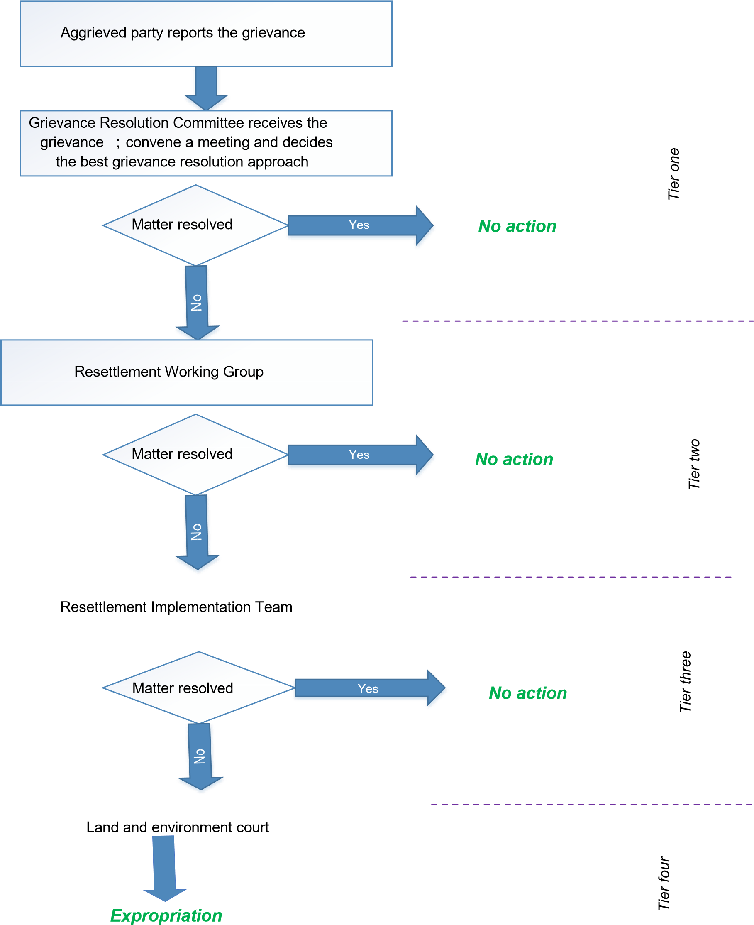

Figure 1.1: Grievance redress procedure

1.4. Monitoring Complaints
In addition to the Grievance Resolution Form, a Grievance Log will be kept by the project implementers indicating the date the complaint was lodged, actions to be taken and personnel or team responsible for the complaint. A Project Liaison Officer or Relocation Expert for the project will monitor and document the progress of all complaints through monthly ARAP implementation status reports.

ANNEXES
- Grievance registration form
- Sample grievance and resolution form
- Grievance log

APPENDIX II: SAMPLE GRIEVANCE REGISTRATION AND RESOLUTION FORM
Name (Filer of Complaint): __________________________________
ID Number (PAPs ID number): __________________________________ Contact Information (mobile phone): ______________________________ Nature of Grievance or Complaint:
_____________________________________________________________________________
_
_____________________________________________________________________________
_

Date Individuals Contacted Summary of Discussion
_____________ _________________ __________________________

Signature_______________________ Date: ____________

Signed (Filer of Complaint): _____________________________________

Name of Person Filing Complaint (if different from Filer): ____________________

Review/Resolution
Date of Conciliation Session: ______________________________________
Was Filer Present? Yes No
Was field verification of complaint conducted? Yes No
Findings of field investigation:
_____________________________________________________________________________
_
_____________________________________________________________________________ _ Summary of Conciliation Session
Discussion:
____________________________________________________________________
_____________________________________________________________________________
_ Issues________________________________________________________________________
_

Was agreement reached on the issues? Yes No
If agreement was reached, detail the agreement below:
If agreement was not reached, specify the points of disagreement below:
_____________________________________________________________________________
_

Signed (Conciliator): ________________________ Signed (Filer): _____________

Signed: ___________________________
Independent Observer

Date: ______________________

APPENDIX III: EXCEL GRIEVANCE LOG

